GEOLOGY OF MID-COAST MAINE

Jane Gneiss, Maine Geological Survey, Augusta, ME, jane.gneiss@maine.gov
John Gneiss, Mount Battie Consultants, Camden, ME, jgneiss@battie.com

INTRODUCTION

The geology of Mid-coast Maine is very interesting with a lot of fascinating rocks and landforms. The rocks are really old and have been through a lot, especially after they were scoured by glaciers during the last Ice Age. This field trip will cover a wide variety of geology in the region (Figure 1). This trip has been modified from another field trip by Gneiss (2008).
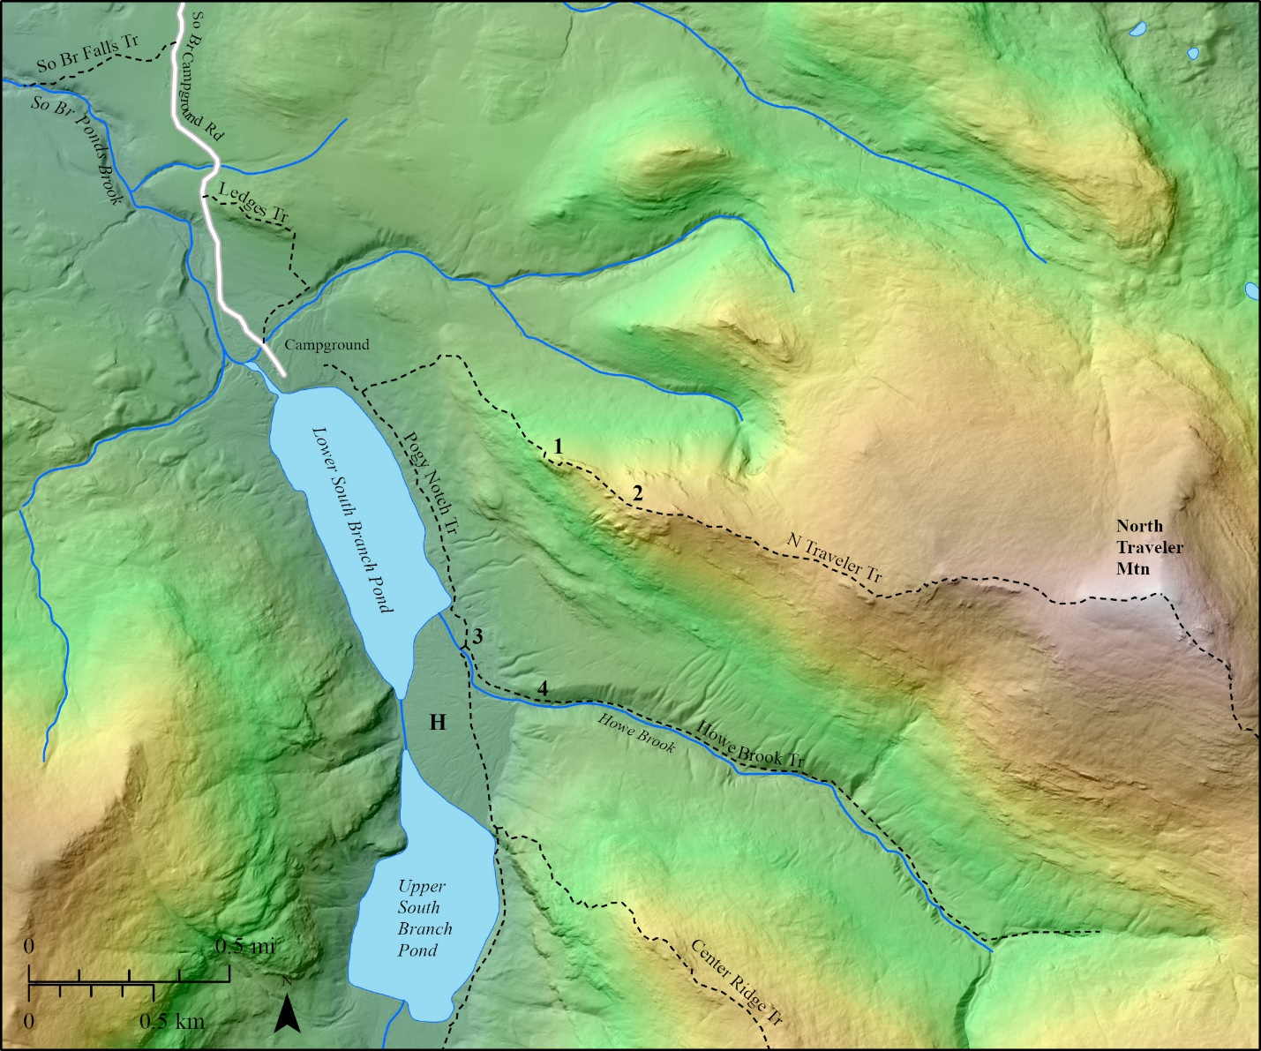
Figure 1. Trip overview map.

More important background information here and so on and so forth.

Bedrock Geology

This is an example of text under a subheading. Rocks, rocks, and more rocks.
Surficial Geology

Sand, gravel, eskers, and deltas.

ROAD LOG

The trip will begin at Bob’s Corner Store, 100 South Street, Middle Earth, ME (044035 m E, 48690000 m N) at 8:00 am. Bring your lunch and wear clothing that is appropriate for the weather. Ticks and snakes may be present. We will consolidate cars and carpool to the trip stops. All locations are on private property and may not be accessed without landowner permission.

Mileage
- Leave Bob’s Corner Store.
  - Turn left on Main Street.
5.5 Turn right into Smith gravel pit entrance (sign just before entrance).

STOP 1: SMITH GRAVEL PIT (044040 m E, 48690050 m N)

Here is a description and some more information about this gravel pit. See the landforms in the area on the lidar map (Figure 2).
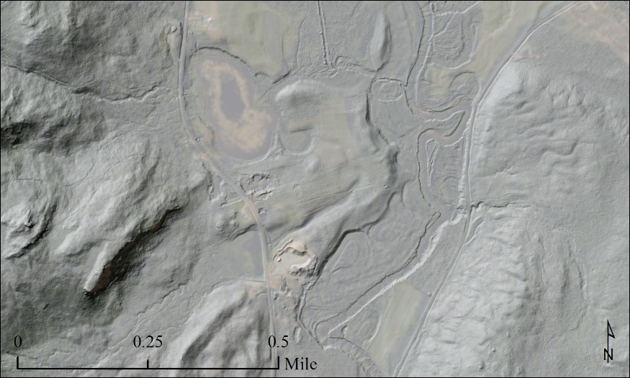
Figure 2. Stop 1 lidar hillshade map.

Mileage
5.5 Turn left onto Main Street from Smith Gravel Pit entrance.
7.5 Go straight through stoplight.
9.0 Turn right into Beach Park.

STOP 2: BEACH PARK (044050 m E, 48690100 m N)

Here is a description and some more information about the bedrock at Beach Park.

END OF TRIP

REFERENCES CITED

Anderson, R.S., Davis, R.B., Miller, N.G., and Stuckenrath, R., 1986, History of late- and post-glacial vegetation and disturbance around Upper South Branch Pond, northern Maine: Canadian Journal of Botany, v. 64, no. 9, p. 1977-1986.
Baxter State Park, 2012, Katahdin, A Guide to Baxter State Park, 7th Edition: Baxter Park Authority, 220 p.
Caldwell, D.W., 1966. Pleistocene and surficial geology between Togue Pond and South Branch Pond, in Caldwell, D.W., ed., Field Trips in the Mt. Katahdin Region, Guidebook for the 58th New England Intercollegiate Geological Conference, p. 51-61.

